Chapter V
Project Testing

PROJECT TESTING:
The proposed system is tested parallel with the software effort that consists of its own analysis, implementation, testing and maintenance.
5.1 Testing methods:-
Software testing methods are traditionally divided into black box testing and white box testing
Black box Testing:
Black box testing treats the software as a "black box"—without any knowledge of internal implementation. Black box testing methods include: equivalence partitioning, boundary value analysis, all-pairs testing, fuzz testing, model-based testing, traceability matrix, exploratory testing and specification-based testing
Advantages:
The black box tester has no "bonds" with the code, and a tester's perception is very simple: a code must have bugs.
Disadvantage:
- A Tester writes many test cases to check something that could have been tested by only one test case,
- Some parts of the back-end are not tested at all.
White box Testing:
White box testing is when the tester has access to the internal data structures and algorithms including the code that implement these.
Types of white box testing:
- API testing (application programming interface) - Testing of the application using Public and Private APIs
- Code coverage - creating tests to satisfy some criteria of code coverage (e.g., the test designer can create tests to cause all statements in the program to be executed at least once)
- Fault injection methods
- Mutation testing methods
- Static testing - White box testing includes all static testing
Grey Box Testing:
Grey box testing involves having access to internal data structures and algorithms for purposes of designing the test cases, but testing at the user, or black-box level. Manipulating input data and formatting output do not qualify as grey box, because the input and output are clearly outside of the "black-box" that we are calling the system under test. Grey box testing may also include reverse engineering to determine, for instance, boundary values or error messages.
Integration Testing:
Integration testing is any type of software testing, that seeks to verify the interfaces between components against a software design. Software components may be integrated in an iterative way or all together. Normally the former is considered a better practice since it allows interface issues to be localised more quickly and fixed.
Regression Testing:
Regression testing is any type of software testing, that seeks to uncover software regressions. Such regression occurs whenever software functionality, that was previously working correctly, stops working as intended. Typically, regressions occur as an unintended consequence of program changes, when the newly developed part of the software collides with the previously existing. Common methods of regression testing include re-running previously run tests and checking whether previously fixed faults have re-emerged.
Acceptance Testing:
It is a pre-delivery testing in which entire system is tested at client's site on real world data to find errors.
Testing can be done on the following levels:
Unit testing tests the minimal software component, or module. Each unit (basic component) of the software is tested to verify that the detailed design for the unit has been correctly implemented.
Integration testing exposes defects in the interfaces and interaction between integrated components (modules).
System testing tests a completely integrated system to verify that it meets its requirements
System integration testing verifies that a system is integrated to any external or third party systems defined in the system requirements.
5.2 Type of Test Performed & Results:
Black Box Testing:
In this strategy some test cases are generated as input conditions that fully execute all functional requirements for the program.
This testing has been uses to find errors in the following categories
- Incorrect or missing functions
- Errors in external database access
- Performance errors
White Box Testing:
In this, test cases are generated on the logic of each module by drawing flow graphs of that modules and logical decisions are tested on all cases.
It has been uses to generate the test cases in the following cases
- Guarantee that all independent paths have been executed.
- Execute all logical decisions on their true or false sides.
Ex: Here,if any subject is selected to download syllabus, automatically syllabus will be downloaded if it had been uploaded.

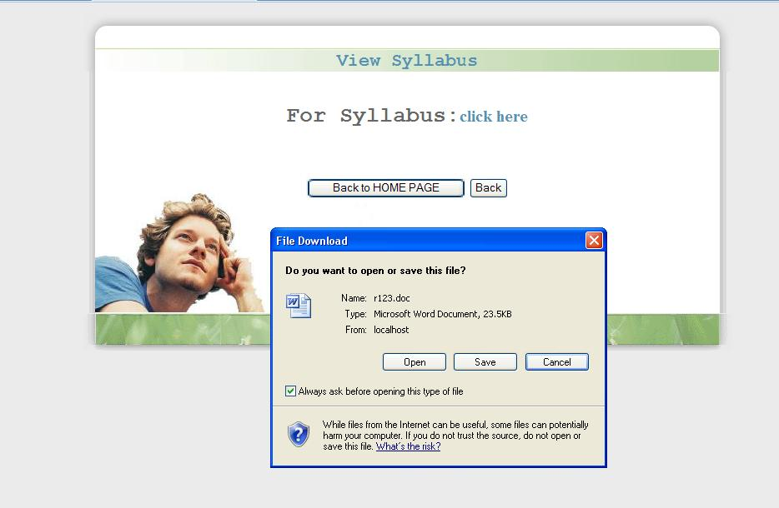
If syllabus is not uploaded then appropriate message will be displayed as follows.
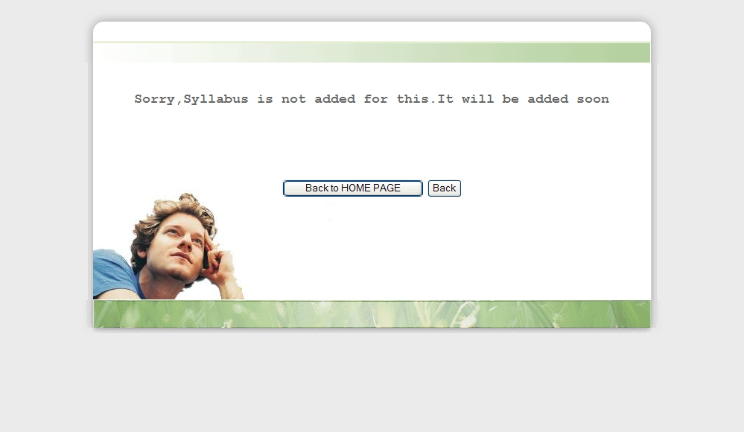
- Execute all loops at their boundaries and with in their operational bounds.
The system has been tested and implemented successfully. In case of erroneous input corresponding error messages are displayed.
Ex: If administrator tries to delete a course or branch that doesn’t exists in database, then the error message(with complete notification) will be displayed as follows.
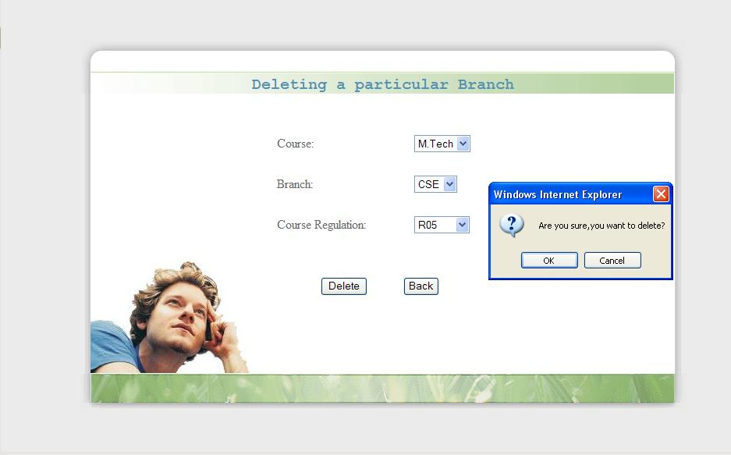
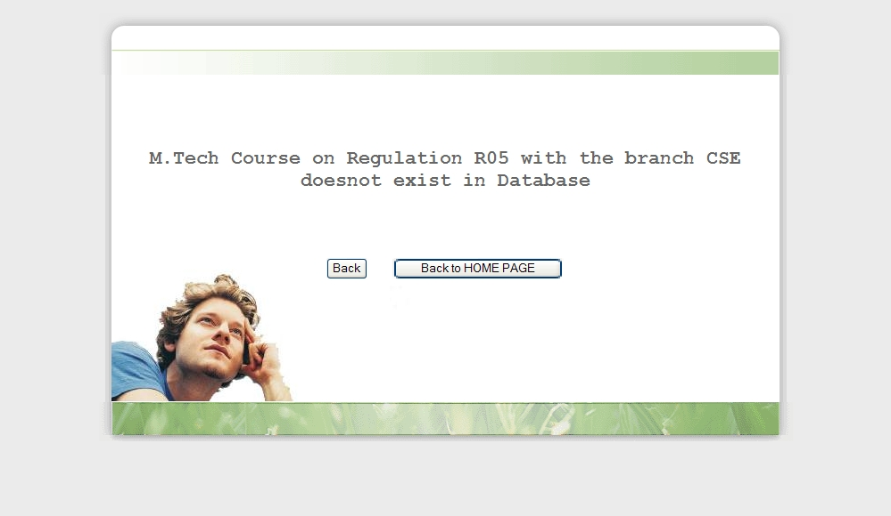
This Program was successfully loaded and executed. Because of good programming there was no error.
The Successful Output Screens are placed in the Output Screens Section.

